The OSSCA Quarterly
May

2019

ATTRACTIONS

Comment from the President, John Johnson
Comment from the Executive Director and Editor of The Quarterly, Gary Avedikian
Comment from the Vice President for Education, Bryan Daniel
Comment from College Coaches
Coach Nancy Feldman, Boston University

Comment from Fellow High School Coaches
Coach Zorro – Sword High School - Favorite practice

Comment from Director of Referees, Don Muenz
Rules Changes for 2019

Comment of Fitness
Muscle Activation Therapy – Jim Vance

Comment from the Sport Psychologist, Dr. Steve Graef
WHAT’S IMPORTANT NOW?

Response to Question of the Month from a Member
Joe Doaks – What are some ideas for increasing fan attendance?

From the President
John Johnson
OSSCA Members,
Materials I wanted to share with you have not arrived as of yet.
They will appear in a supplement to the May Quarterly as soon as possible.
Yours in Soccer,
John Johnson
OSSCA, President
Wadsworth High School

From the Executive Director of OSSCA
Gary Avedikian

I think we all share a real concern about the number of Red Cards recorded last season by both players and coaches. There will always be those looking for a reason to kill high school soccer particularly because of the growing concern about head injuries in another sport. Many parents, including my own son who played football won’t let their kids play it. That means that there is more pressure about the potential and real loss of athletes to soccer.
With these things in mind, we should do everything in our power to control ourselves and our players so that we aren’t fueling the anti-soccer people out there and giving authorities a reason to take action against our sport.
Remember, our officials are tremendously powerful compared to football and basketball. What they get 15-yard penalties for or two foul shots for, we can get a direct red card. Our rules and penalties are designed to stop infractions and not to create strategic advantage for violating the rules.
We must constantly teach self-control, respect for an opponent, and the rules of the game. Remember, if your opponent isn’t worthy of your respect, what did you accomplish with a victory?
I’ve included some information on something I discovered through Jay Martin. We’ve both had full knee replacements and he put me on to MAT. Muscle Activation Therapy. It’s fantastic.
There are a series of simple, quick exercises that we can do with our players or ourselves that will improve strength, improve coordination, lower the risk of injury by creating less likelihood of muscle tears and ACL injuries, and less pain.
It turns out that our gluts are a major set of muscles that don’t get much work by anyone who sits all day. That can be us and the student-athlete.
Google MAT and you will find a series of glut exercises that work out a series of muscles as well.

Comment from the Vice President for Education
Bryan Daniel

Three Versatile Go-To Activities with Multiple Applications/Themes
Many times, we coaches over complicate our sessions with the newest trend or session we see online or on social media. However, there are many activities that can be deployed in countless different ways, with different progressions/variations, to bring out a wide array of coaching points. Listed below are a few straightforward “go-to” activities that can be modified to fit the needs of just about any level team and just about any focus.
The first is a versatile technical warm up activity that is extremely simple to implement, yet can be highly effective in ingraining players with proper receiving, passing, movement, and communication habits. The second and third are more game-like activities that can be used to address a wide variety of coaching points in attack, defense, and transition moments. See the “Application Ideas” section below each diagram for several topics that can easily be addressed with each activity. Please feel free to reach out to me via Twitter with questions/comments.
Bryan Daniel
VP of Education
Head Coach, Indian Hill High School [Cincinnati]
Twitter: @MisterBDaniel

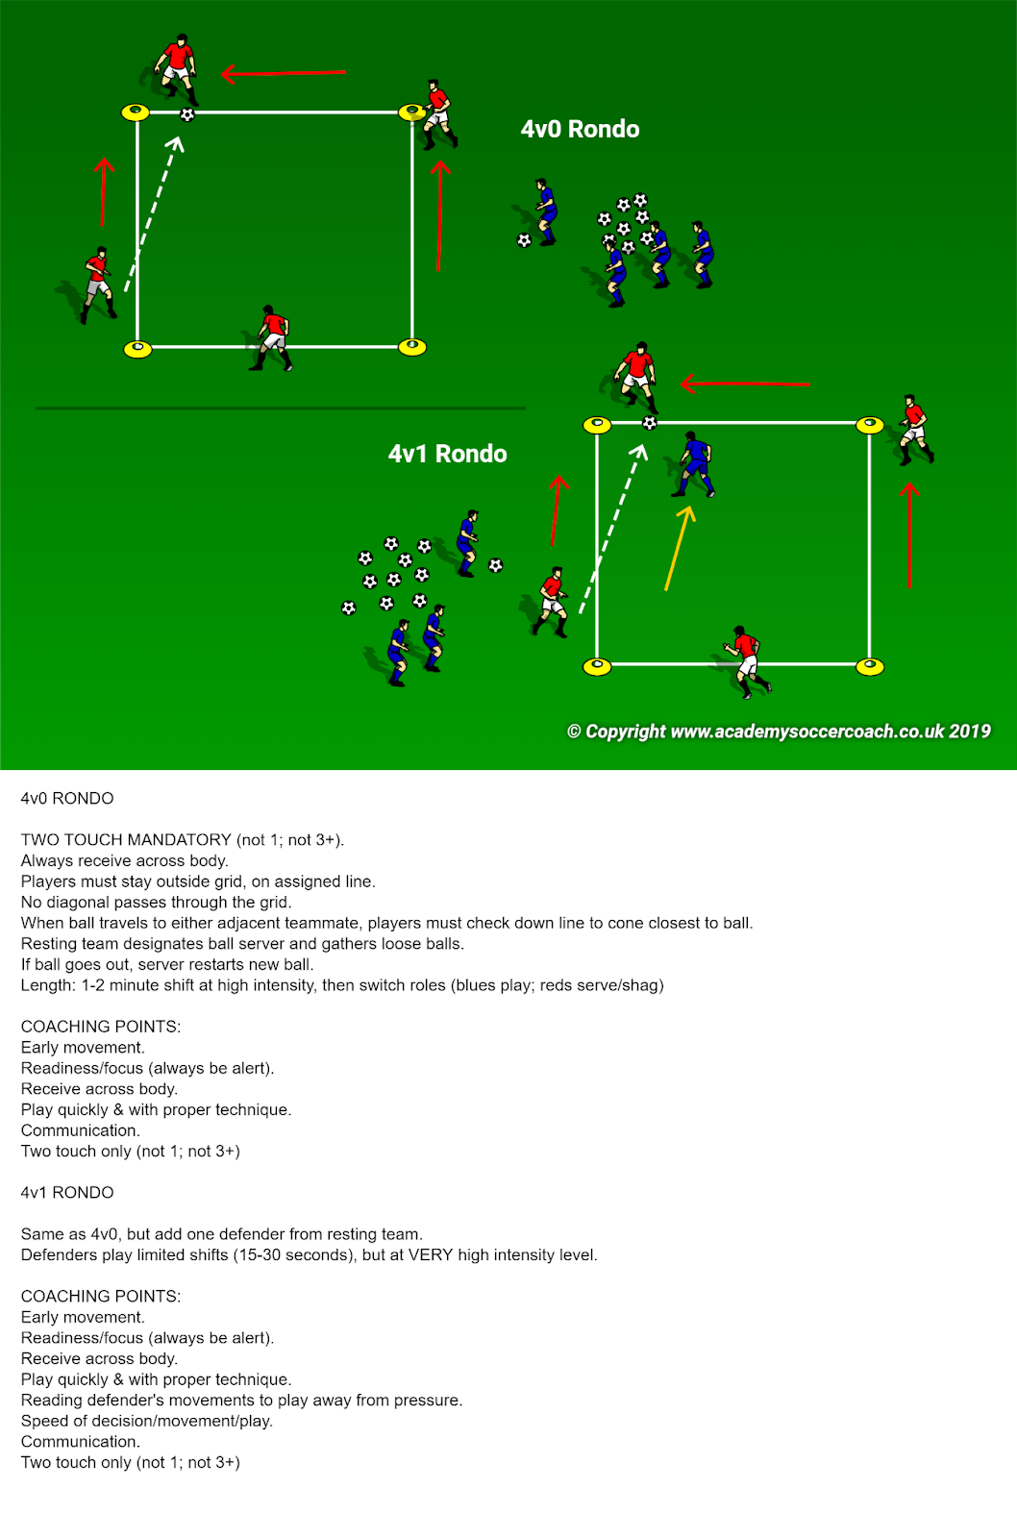

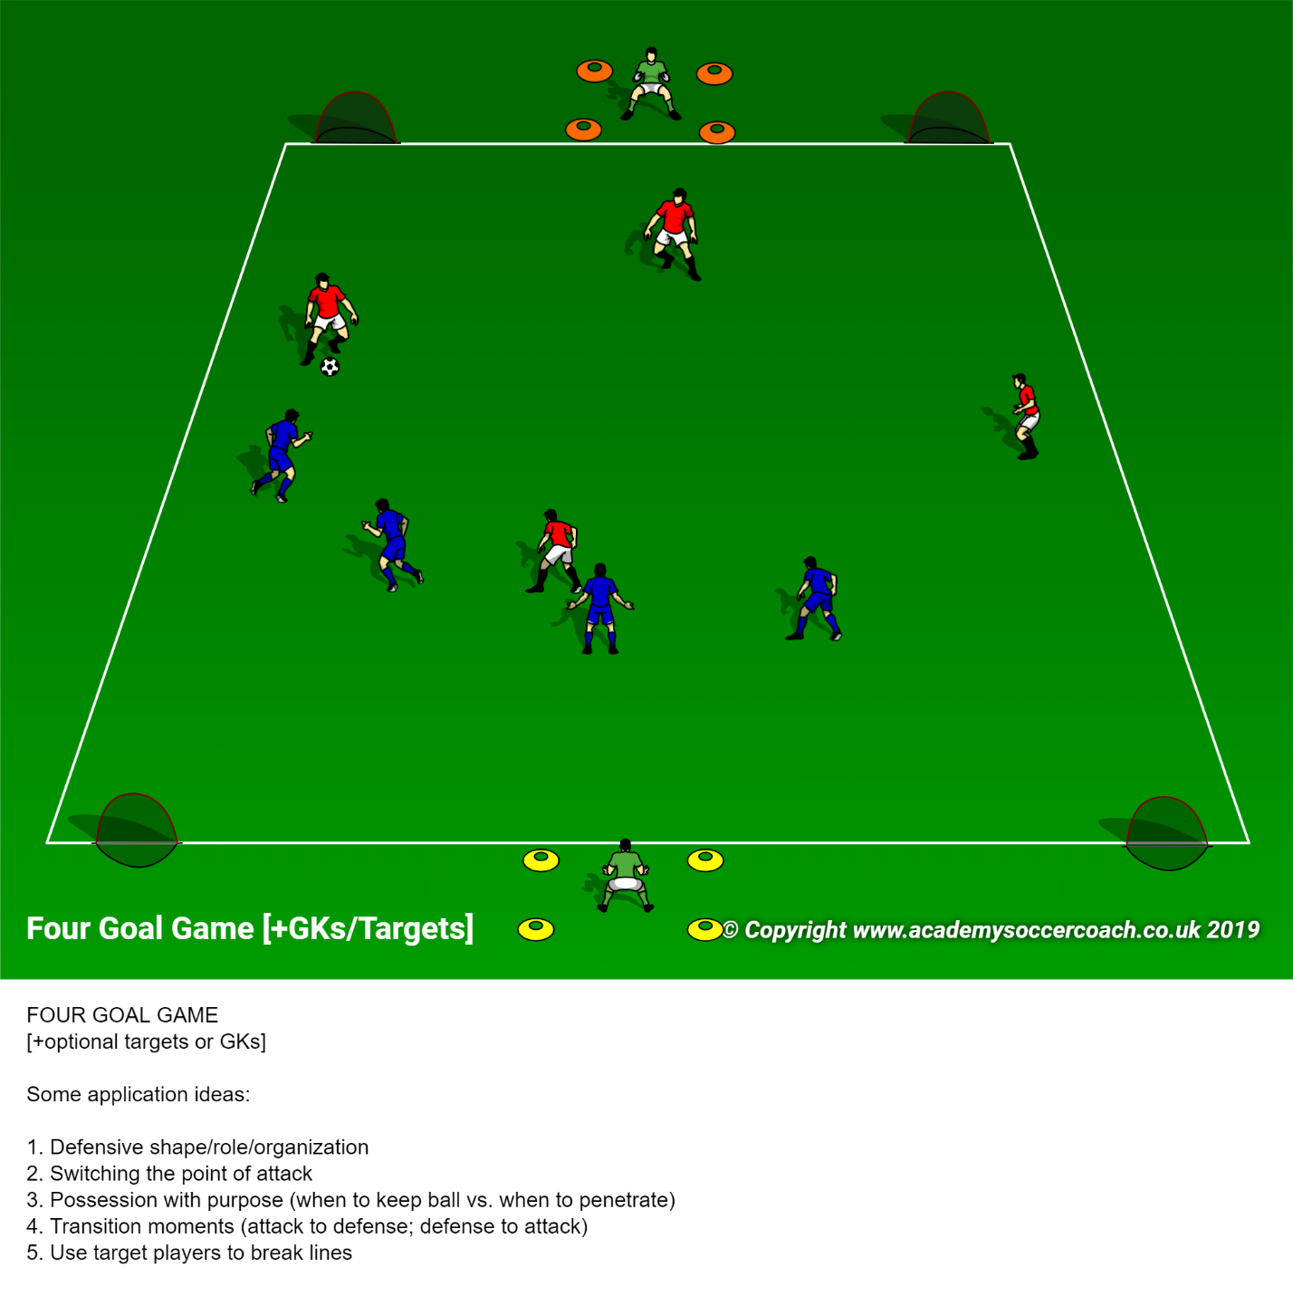

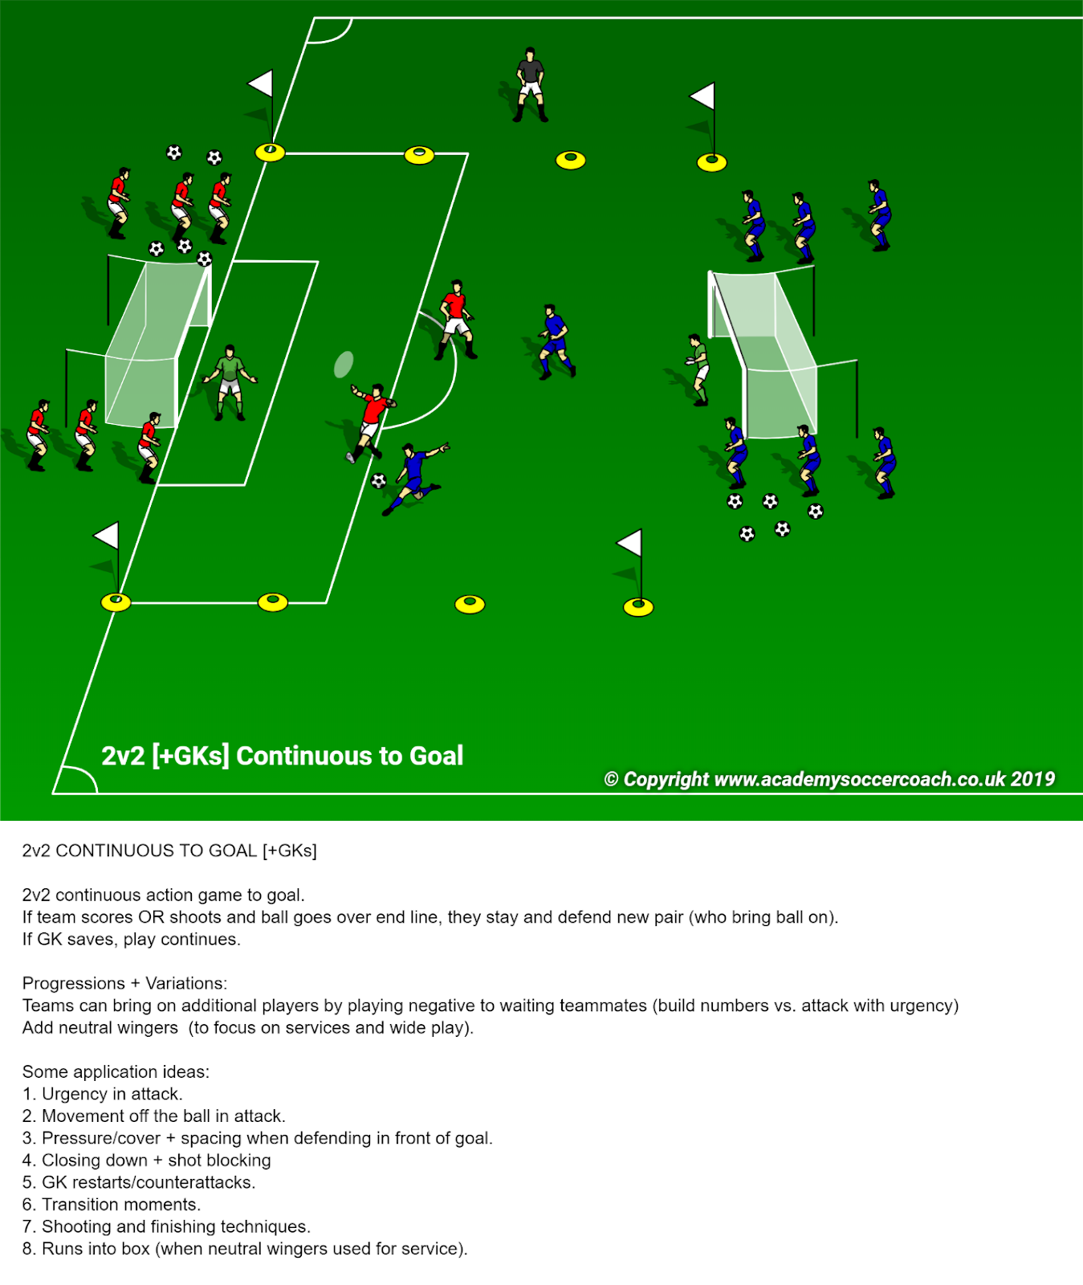

College Coach –
Nancy Feldman, Head Women’s Coach, Boston University

Keys to future success –
Let me start by saying, there are no guarantees if you only define
success as being a champion, or measured by external recognitions.
I sometimes overhear parents say something like this “I have spent so
much money and time for Suzie’s youth soccer experience, I hope the
investment pays off”. What is the meaning of this????? Is it to land a
scholarship, or is it to foster the development of their child to
complement all the other ways that their offspring grows up to be
healthy, happy, able to cope with what life throws at them, and find joy
and passion in their play and work.
What is a success story? How do we define success? Let me come at
this from a 30 + year college coach point of view.
What are the keys to future success in collegiate soccer and more
importantly, what should a student-athlete (and their parents) expect
to get out of the experience.
Keys –
1) Passion and love to play and compete – this is the most important
of all. There are not only good but there are challenging times in
the path of collegiate athletic careers. What gets you through?
The joy and passion to play the game. To want to be in the arena!
To love it so much, you can see past the challenge and remind
yourself how lucky you are to be able to do this.
2) Surround oneself with good people and the right
environment/culture – selection of the type of school, academic
program and culture of the team. Finding the best spot for you!
Not your teammates, coaches or parents. What is important to
you and which environment will give you the best opportunity to
realize your full potential. This is the support network to getting
through challenges you might face, being able to lean on the
people around you, on your teammates, your coaches, and the
other aspects of the school you are at that you chose for reasons
that were important to you.
3) Persistence – having a drive and mentality to develop. Learning
how to be comfortable being uncomfortable. It is not a straight
line, lots of falling down and getting up.
4) TTP – Trust the process, balancing expectations with belief and big
hairy audacious goals (BHAG). It takes time and patience to reach
lofty goals. Celebrate small steps along the way, keep your eye on
the prize. And try to enjoy the growth process as you measure
yourself against yourself.
5) Grit – persistence over time. We can both learn this and teach
this through sport and it is a significant life skill in terms of future
achievement and satisfaction.
6) Be a good teammate – How will you be remembered, what do you
want your legacy to be and what kind of lasting impression will
you make on people and the organization? Learning tolerance
and acceptance. Learning how to give and get support. Be
inspired by the common goal and what your part is in achieving it.

From Ohio High School Coaches
Coach Zorro – Sword High School - Favorite practice

From the Director of Referees for the OHSAA
Don Muenz
2019 NFHS Soccer Rules Changes Explained
By Don Muenz, Soccer DoD
New 3.4.2: “The clock shall be stopped when a substitute by the team in the lead is beckoned on the field in the final five minutes of the second period only.”
New 7.4.3: “The clock shall be stopped when a substitute by the team in the lead is beckoned onto the field in the final five minutes of the second period only.”
The new rules apply only to second half of regulation play, because our postseason overtimes are sudden victory.
When the leading team subs, the clock is stopped when the subs are beckoned on, and the clock restarts only after all subs are completed, a second whistle is given and the ball is properly put into play, 9.1.3.
The clock is stopped where the leading team and the trailing team both sub.
Examples:
A.) In the last five minutes of the second half, only the trailing team subs. The clock does not stop.
B.) In the last five minutes of the second half, only the leading team subs. The clock is stopped when the referee beckons on the sub and the clock restarts after the subs are completed, the referee gives a second whistle and the ball is properly put into play.
C.) In the last five minutes of the second half, both the leading team and the trailing team sub. The clock is stopped when the referee beckons on the sub and the clock restarts after all of the subs are completed, the referee gives a second whistle and the ball is properly put into play.
Because this new stoppage rule is part of “regular” timing, the Ohio Mercy Rule, 2019 OHSAA Soccer Regulation 10(A)(1.7), overrides it.
“Goal Differential/Running Clock – During any regular season or tournament contest, any time the score differential reaches 6 goals or more AFTER the first half of the contest, a running clock shall be used. After the 6-goal differential has been met but the score drops below 6 goals, the clock reverts to regular timing. The clock shall be stopped only for an injured player on the field or when there is any unusual delay deemed necessary by the officials.”
Where the Ohio Mercy Rule applies, there is no stoppage for subs in the final five minutes of the second half.

Amended 4.1.1(h): New for this year. The numbers of all players shall be of a solid, color contrasting with the jersey (or shorts or pants) and clearly visible.

Amended 4.2.2 Situation A: This play ruling has been amended to permit use of knotted prewrap for hair control or sweat prevention. 4.2.2 Situation A(c): “During pregame warm-up, the referee observes that (e) A6 is wearing knotted prewrap around the head. RULING: Legal in … (e) if worn to control the player’s hair or prevent sweat on the face.”

Amended 4.3 Improperly Equipped Players (18-1-1u)
“Cautions will not be issued for improperly equipped player(s).
If not immediately correctable, improperly equipped player(s) shall be instructed to leave the field of play when the ball next ceases to be in play. The player(s) may be replaced. The removed player(s), if not replaced, may re-enter at the next dead ball only after reporting to an official, who shall be satisfied the player’s equipment and uniform are in order. Play shall not be stopped for an infringement of this rule except that the referee may stop play immediately where there is a dangerous situation.”
18.1.1(t) “ILLEGALLY EQUIPPED – A player not wearing equipment required by rule or wearing an item/items not allowed by rule.”
18.1.1(u) “IMPROPERLY EQUIPPED – A player wearing legal equipment that is being worn incorrectly or becomes illegal during play.”
Explanation: Amendments expressly permit improperly equipped players to fix the defect on the field and remain in the match or to be replaced by a substitute from the bench or a substitute who has already reported in. A team with an improperly equipped player does not have to play shorthanded. It may elect to do so. Before an improperly equipped player returns to play, the player must be inspected by an official to confirm that the improper condition has been rectified.
Remember, no one is cautioned for improper equipment.

Amended 5.3.1(d): Referees may now use one or both hands in signaling advantage. This adopts the FIFA Law Amendment of a couple of years ago.

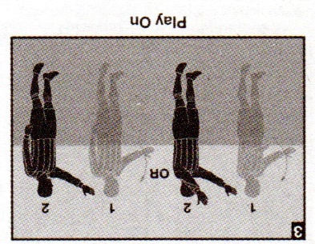

Amended 6.2.3(f): “The official timer shall: (f) signal the last two minutes of any period when applicable.”
Explanation: The official timer is to state OVER THE PUBLIC ADDRESS SYSTEM that there are two minutes remaining in any half of regulation or overtime play. This is to be done vocally, NOT with a horn, whistle, or other noise-making device.

Amended 6.2.3(g): “The official timer shall: (g) signal the last two minutes before the end of the interval between the periods.”
Explanation: The official timer is to state OVER THE PUBLIC ADDRESS SYSTEM that there are two minutes remaining in the interval. This is to be done vocally, NOT with a horn, whistle, or other noise-making device. This new requirement applies to the interval between halves of regulation play and the interval between the end of regulation play and the first half of overtime during the postseason tournament. It cannot apply to the interval between overtime periods, which is only two minutes long, or the interval between the end of the second overtime and kicks from the penalty mark, which is also two minutes.

Rule 9 has undergone substantial change, resulting in its being closer to, but not quite the same as, FiFA’s Law VIII.2.
It is expected that players and coaches, going forward, will continue to exercise the highest degree of sporting behavior to which our high school game has long become accustomed.
Let’s look at it, piece by piece.
9-2-1 | The game is restarted with a drop ball:  a. when the ball is caused to go out of bounds by two opponents simultaneously;  b. when the ball becomes deflated;  c. following temporary suspension of play for an injury or unusual situation and a goalkeeper is not in possession of the ball  d. when simultaneous fouls of the same degree occur by opponents.  Rationale: This rule changes the awarding of a free kick to a drop ball thereby possibly creating a scoring opportunity for a team underserving.

NEW 13.2.3(b) also comes into play. “The following indirect free kicks are taken from where the ball was when the referee stopped play: (Subject to restrictions in 13.1.3 and 13.1.4) … (b) for temporary suspension of play for an injury or unusual situation and the goalkeeper has possession of the ball (9.3); … .”

Amended 9.3 is also pertinent:
9-3 | In case of a temporary suspension due to injury or any unusual situation the game shall be started by a drop ball at the point where the ball was when the play was suspended (except as noted in 14-1-7), provided the ball was not in the goal area and not in the possession of the goalkeeper. 12-8-2  Rationale: This change will eliminate free kick opportunities that often create scoring opportunities that are not deserved.

2019 Comments on the Rules: 9.2.1: “In situations where the play is temporarily suspended for an injury, play will now be resumed with a drop ball unless the goalkeeper was in possession of the ball at the time of the stoppage. This change eliminates the awarding of an indirect free kick to a team and prevents an otherwise undeserved potential goal-scoring opportunity.”
2019 Comments on the Rules: 9.3: “Consistent with changes made in Rule 9.2, this change eliminates the awarding of an indirect free kick when play is temporarily suspended due to an injury or other unusual situation. The only exception to this is when the goalkeeper is in possession of the ball at the time of the stoppage.”
Where the referee is required to stop play for an injury or any unusual situation, an indirect free kick will no longer be given to the team in possession, unless the goalkeeper possesses the ball with hands or like a field player, WITHIN THE GOALKEEPER’S OWN DEFENSIVE PENALTY AREA. Absent goalkeeper possession, there would be a dropped ball.
The goal of these amendments is to prevent the award of an “undeserved potential goal-scoring opportunity.” Limiting the award of an indirect free kick to the goalkeeper when in possession within their own defensive penalty area achieves that goal. Whether the goalkeeper possesses the ball as a goalkeeper or as a field player, both possessions within the penalty area are treated consistently and equally. Equal treatment prevents giving the goalkeeper’s team an indirect free kick outside of that penalty area, when the goalkeeper has pushed up on the attack or left her own penalty area. This interpretation also prevents award of a potentially contested dropped ball, an underserved potential goal-scoring opportunity for the attackers, where the goalkeeper possesses the ball as a field player within his own penalty area and play is stopped for an injury or other unusual situation. This latter instance becomes more important as goalkeepers’ foot skills continue to improve and their teammates increasingly pass the ball to them to avoid the high-pressure tactics of their opponents.
Okay, what is goalkeeper possession?
With the hands: 12.4.2(a) states in pertinent part: “Possession or control of the ball includes any time the goalkeeper has the ball trapped by either or both hands, or when bouncing it to the ground or when releasing the ball into play.” I would add that if the goalkeeper has the ball trapped with one or both hands against his/her body or that of a teammate (i.e., not a teammate’s body area subject to handling), the ground, the goal or a referee, would also be possession. Trapping the ball against an opponent would not be possession.
As a field player possesses the ball: 18.1.1(ii): “POSSESSION – A live ball controlled by a team, player or a goalkeeper. A controlled ball is one which may be passed, thrown, dribbled or shot on goal by a player.” 18.1.1: “PLAYING DISTANCE – The distance between the player and the ball which the official judges to be adequate to control the ball. It will seldom exceed two steps (six feet).”
Examples:
(A) B5 kicks the ball back to her goalkeeper, who is within her own defensive goal area. While the ball is at the goalkeeper’s feet, ready for her to play it, the referee whistles play dead for a serious injury to A6, who is lying on the ground near the halfway line. Restart: Indirect free kick to the goalkeeper’s team from any spot on the lines describing the goal area or wholly within the goal area, 13.1.3.
(B) B5 shoots on goal and the goalkeeper catches the ball, holding it in his hands just outside of his own goal area. The referee whistles play dead for a serious injury to B6, who is lying on the ground near the halfway line. Restart: Indirect free kick for the goalkeeper’s team from the spot where the ball was when the whistle stopped play.
(C) B5 kicks the ball back to her goalkeeper, who is within her own defensive penalty area. The goalkeeper then dribbles beyond her penalty area. While the ball is at the goalkeeper’s feet, ready for her to play it, the referee whistles play dead for a serious injury to A6, who is lying on the ground near the halfway line. Restart: Dropped ball from the spot where the ball was when the whistle stopped play. Rationale: Though in possession of the ball, the goalkeeper was outside of her defensive penalty area.
(D) The ball is in Team A’s goal area, but no one is in possession when the referee stops play for an injury. Restart: A dropped ball on the goal area line parallel to the goal line, nearest where the ball was when play was stopped. The goalkeeper may participate in the dropped ball.
(E) The ball is in Team B’s defensive penalty area (not the goal area). Team A is in possession when the referee stops play for a serious injury. Restart: A dropped ball from the spot where the ball was when play was whistled dead.
Summing up, where the goalkeeper, within his/her own defensive penalty area, is in possession of the ball, either as goalkeeper or as a field player, at the time that play is stopped for an injury or unusual situation, the goalkeeper’s team will be awarded an indirect free kick. At any other such stoppage, there will be a dropped ball.

Amended 9.2.3 Number of participants at a dropped ball
9-2-3 | The ball is dropped by an official from waist level to the ground. Any number of players may contest a dropped ball (including the goalkeepers); a referee cannot decide who may contest a dropped ball or its outcome.  Rationale: This addition helps to provide clarity in the application of this rule.

Any number, from one to twenty-two, may participate, but may not interfere with, the dropped ball process. The referee may not decide who takes part in the dropped ball or determine the outcome of a dropped ball.
2019 Comments on the Rules: 9.2.3: “This change clarifies the procedure followed when resuming play through a dropped ball. It allows any number of players to take part in the dropped ball (including only one player) and specifically states the referee the referee cannot decide who may take part in the dropped ball.”

New 9.2.6: a dropped ball is an indirect restart and must be touched by two players before a goal can be scored.
9-2-6  NEW | ART. 6 . . . If a dropped ball enters the goal without touching at least two players, play is restarted with a goal kick if it enters the opponent’s goal or a corner kick if it enters the team's own goal.  Rationale: This addition helps to avoid confusion and allow the rule to be more equitable under the circumstances.

NEW 10.1.3: “A goal MAY NOT be scored directly from a/an: … (g) dropped ball.”
The new rule mirrors FIFA Law VIII.2.
Examples:
(A) A9 and B4 participate in a dropped ball. A9 dribbles twice and kicks the ball directly into Team B’s defensive goal. Restart: Goal kick. Two players did not touch the ball.
(B) A9 and B4 participate in a dropped ball. B4 touches the ball. A9 then kicks the ball directly into Team B’s defensive goal. Restart: Kickoff for Team B. The goal counts because two players touched the ball.

2019-20 NFHS SOCCER RULES CHANGES

3-4-3  NEW | The clock shall be stopped when a substitute by the team in the lead is beckoned on the field in the final five minutes of the second period only.  Rationale: Rule affected by change in 7-4-3.
4-3 | Improperly Equipped Players (18-1-1u)  Cautions will not be issued for improperly equipped player(s).  If not immediately correctable, improperly equipped player(s) shall be instructed to leave the field of play when the ball next ceases to be in play. The player(s) may be replaced. The removed player(s), if not replaced, may re-enter at the next dead ball only after reporting to an official, who shall be satisfied the player’s equipment and uniform are in order. Play shall not be stopped for an infringement of this rule except that the referee may stop play immediately where there is a dangerous situation.  Rationale: The change corrects an injustice. For the far more serious infringement of illegal equipment, the offending team does not play shorthanded. For the less serious offense of improper equipment, they are required to play shorthanded. The change addresses this inequity.
5-3-1d | The officials shall:  (d) call out "play on" and, with an underswing of one or both arms, indicate a foul which was observed but shall go unpenalized because penalizing the offending team would give an advantage to the offending team. If the referee applies the advantage, which was anticipated but does not develop at that time, the referee shall penalize the original offense.  Rationale: This change permits the use of one arm to signal advantage.
7-4-3  NEW | The clock shall be stopped when a substitute by the team in the lead is beckoned onto the field in the final five minutes of the second period only.  Rationale: Coaches in the lead will make multiple substitutions in the later stages of the match. This tactic is being used as a time-wasting ploy. Adding this rule will help the game to be decided by the players and not a coach who is wasting time when in the lead. These substitutes are usually players from the far side of the field that take more time off the clock. This addition would stop this practice.
9-2-1 | The game is restarted with a drop ball:  a. when the ball is caused to go out of bounds by two opponents simultaneously;  b. when the ball becomes deflated;  c. following temporary suspension of play for an injury or unusual situation and a goalkeeper is not in possession of the ball  d. when simultaneous fouls of the same degree occur by opponents.  Rationale: This rule changes the awarding of a free kick to a drop ball thereby possibly creating a scoring opportunity for a team underserving.
9-2-3 | The ball is dropped by an official from waist level to the ground. Any number of players may contest a dropped ball (including the goalkeepers); a referee cannot decide who may contest a dropped ball or its outcome.  Rationale: This addition helps to provide clarity in the application of this rule.
9-2-5  NEW | ART. 5 . . . The ball shall be dropped again if it touches a player before it touches the ground or leaves the field of play after it touches the ground without touching a player.  Rationale: This addition helps to avoid confusion and allow the rule to be more equitable under the circumstances.
9-2-6  NEW | ART. 6 . . . If a dropped ball enters the goal without touching at least two players, play is restarted with a goal kick if it enters the opponent’s goal or a corner kick if it enters the team's own goal.  Rationale: This addition helps to avoid confusion and allow the rule to be more equitable under the circumstances.
9-3 | In case of a temporary suspension due to injury or any unusual situation the game shall be started by a drop ball at the point where the ball was when the play was suspended (except as noted in 14-1-7), provided the ball was not in the goal area and not in the possession of the goalkeeper. 12-8-2  Rationale: This change will eliminate free kick opportunities that often create scoring opportunities that are not deserved.

Fitness: MAT = Muscle Activation by Jim Vance

7 Pre-Workout Activation Routines for Better Performance
MAY 30, 2015 · BY JIM VANCE

Jim Vance is an elite endurance sports coach, author, and sport technology and training consultant based in San Diego, California. He is the personal coach 2016 US Olympic triathlete Ben Kanute, guiding him to 2017 performances of victory at Escape from Alcatraz and Island House Triathlon, as well as a 2nd place finish at the 70.3 World Championships.
Jim is also the Head Coach for Formula Endurance, a USA Triathlon High Performance Team, focused on developing top junior triathletes, as part of the Olympic Pipeline. Jim is also the Head Varsity Swim Coach at Coronado High School, (where he coached a 2016 All-American swimmer), and has coached elite National Champions, World Championship podium performances, countless Ironman World Championship qualifiers, and been a training consultant for US Olympians. Jim has written two books – Triathlon 2.0 and Run with Power, and co-edited Triathlon Science with best-selling training author, Joe Friel.

Activating your muscles before you start your workout can help you recruit more muscles and work more efficiently. Use these seven activation exercises to get the most from your body.
Have you ever stumbled out of bed and wondered why it takes so long for you to gain your balance or be able to walk straight? Or have you ever sat for so long in a car or at a desk that the first few steps you wonder if your legs are listening to what your brain is telling them to do?
These are just a couple examples of how the connections between our brains and our muscles are sometimes not functioning properly due to periods of non-use. In the world of physical therapy, it is called neuromuscular activation. “Neuro” comes from the nervous system, which sends the signals from the brain to the “muscular” system, to activate the muscles.

Physical Therapy
Many physical therapists work with individuals just trying to get them to utilize muscles which aren’t firing or being used in common movements which would greatly enhance the strength and stability of the person during the movements. Most athletes scoff at this idea, but the research shows significant performance differences with neuromuscular activation improvements and some simple routines prior to bouts of exercise can be very effective at improving activation. For example, most athletes have seen dramatic neuromuscular improvements in the weight room, just in the first few weeks of lifting weights. It takes six weeks for athletes to show muscle growth from strength training, so those first six weeks of strength gains from those routines is almost entirely neuromuscular adaptation and improvements in activation.

Consequences
So, what does this mean for you? In simple terms, the more muscle fibers and motor units you recruit in a movement, the more powerful the movement. If you don’t utilize your glutes or quads effectively when pedaling your power drops. If you are a swimmer and don’t engage your lats or utilize your core effectively, you swim at slower speeds. If you’re a runner and your calf muscles aren’t firing as well as they should, you run slower. These dips in activation can come from simply brief periods of not actively using the muscles, and they need to be re-tuned and sharpened.

Activation
All athletes, from elite to beginner, sit or go through periods of little movement, be it sleep, travel, work, or recovery. When it is time to work out or race, you want the body to be ready to perform, with pathways from the brain to the muscles, through the central nervous system, to be clear and communicated well, so maximum performance can happen.
Here are seven neuromuscular activation routines you can do before every workout or race to help you. These only need to be done a couple times each, for brief periods of 5 to 7 seconds. That means you can run this whole routine in less than 2 minutes. Short and effective!

1. STORK
Standing on one leg, balance so the rest of your body is as perpendicular to the ground as possible, nice and straight, with your arms spread out. Hold this position for 5 to 7 seconds on each foot, once or twice through each foot. Chances are, your balance will be greatly challenged, more than you expect for such a simple movement, proving the need for the exercise. For an additional challenge, do this exercise with your eyes closed.
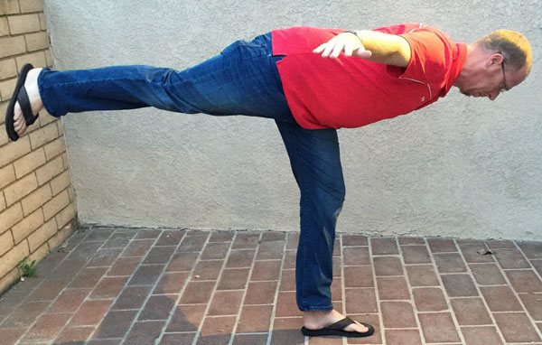

2. BEAR CRAWL
Crawling on the ground, on hands and feet, with butt down, is probably one of the best activation exercises you can do. It forces the shoulders, arms and chest, to stabilize the upper body, the core to be engaged connecting the legs and upper body, and of course the legs are driving the body forward. Simply doing this for about 15 feet is an effective activation technique.

3. SINGLE LEG BALANCE AND LEAN
With arms lifted up and behind your ears, activate your core and lean back while standing on one foot, and pointing the other foot in the same angle of the upper body. If you do this correctly, you will find your stomach tensing up, and likely your whole body shaking. Do this for both feet, holding 5 to 7 seconds on each foot, twice through. For an additional challenge, do this exercise with your eyes closed.
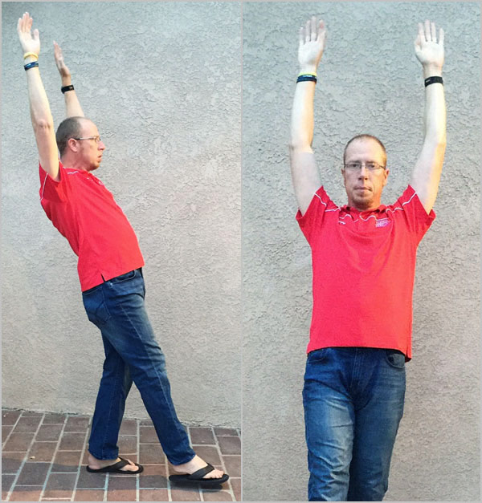

4. KNEE LIFT AND BACK
This exercise activates the hip flexors, the quad, the hamstring and the glutes. Lifting the knee at a 90 degree angle, hold it up front for about 5 seconds, then while maintaining the 90 degree bend of the knee, shift it back so the glute and hamstring pull to hold it in position. Do this for each leg, twice through.
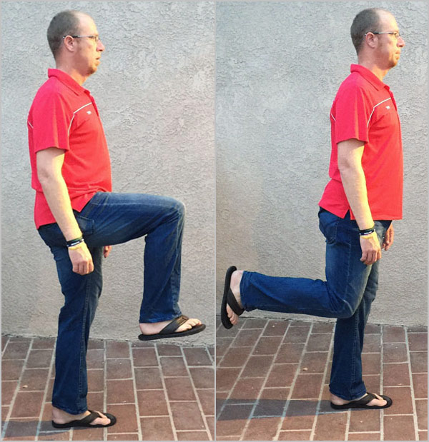

5. CALF RAISES
Standing in place, simply raise up onto your toes, twisting or pivoting on your toes to shift your ankles and heels outward, then back inward, then bring your feet back down to the ground fully, in about 3 to 4 seconds for the full cycle. Again, 5 to 7 routines of this will be adequate.

6. LAT PULL-DOWNS
Standing in place, simply lift your hands up and pretend to pull down on a bar. Five to 7 routines of this, feeling the lats activate is adequate.
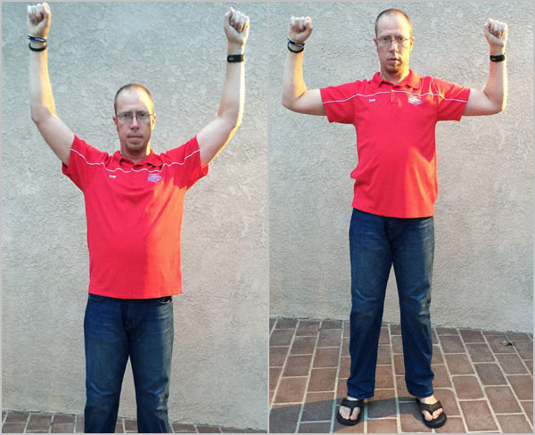

7. CRISS-CROSS ARMS
Standing with your arms extended out to your sides and the palms facing up, bring them all the way across the front of your body with palms facing down. For additional challenge, do this while standing on one leg instead of two, with the free leg hanging, slightly bent.
Take the two minutes it takes to do these exercises before your workout begins and you will likely notice a clear difference in performance and how you feel during the sessions.
(MAT used by Ohio Wesleyan Men’s Soccer Program with the therapist)

From the Sports Psychologist
Dr. Steve Graef, PhD
Counseling/Sport/Performance Psychologist for Ohio State University Athletics
WHAT’S IMPORTANT NOW?
I’m on the final day of a four day workweek and I am co-facilitating a development center that is in creditably involved and kick;;;. all while maintaining client care and having a private practice, answering emails, answering phone calls. I could have found myself getting incredibly overwhelmed. There was 100% that potential. My saving grace, to be honest with you, identifying to myself in any given moment what’s important now. By identifying what’s important now it sequences out this otherwise overwhelming pile of stuff and it makes and it makes much more streamlined in order for me to more effectively tackle it with much less anxiety. When you find yourself getting overwhelmed, think about WHAT’S IMPORTANT NOW?

From A Member: Questions of the Month

Gary,
What are some cool ways to attract fans to our games?
Joe Dragon
Lock Ness HS

Editor Answers: How about having a sky diver bring the game ball to the center circle before the game in exchange for advertising the sky diving club at half-time of all home games.

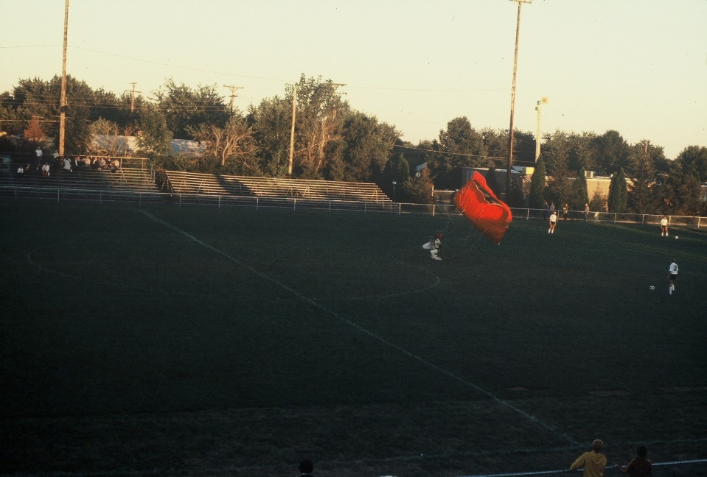

How about getting a radio-controlled model club to bring some airplanes to do tricks over the field at half time? This will get kids to get their parents to bring them to the game. You need to advertise this event in your middle school and elementary school settings.

